Experiment Instructions

Thank you very much for your participation in this experiment.

This is an economic decision making experiment in which you can win different sum of money: 10, 15, 30 or 50 euro.

In each trial you will see two rectangular urns one on the left and the other on the right as illustrated in the figure 1 below. Inside each urn there is an amount of red and blue balls. The proportion of red and blue balls is indicated by the size of the colored areas over the respective urn.

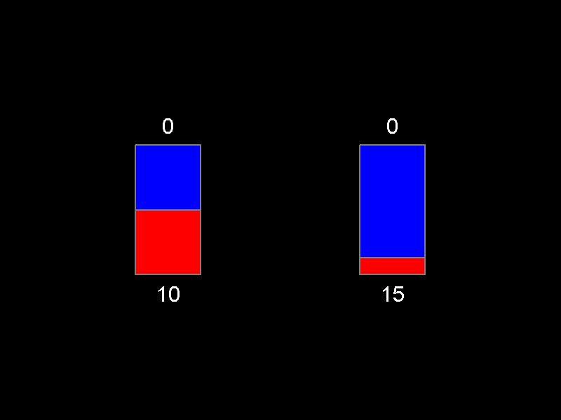

Figure 1.

For instance, in the figure above, the probability to draw a red ball and the probability to draw a blue ball are the same in the urn on the left. However, the probability to draw a red ball is much lower than the probability to draw a blue ball in the urn on the right.

Sometimes you will not be able to know the exact proportion of red and blue balls inside an urn due to the presence of an occluder over it as shown in the following figures 2 and 3.

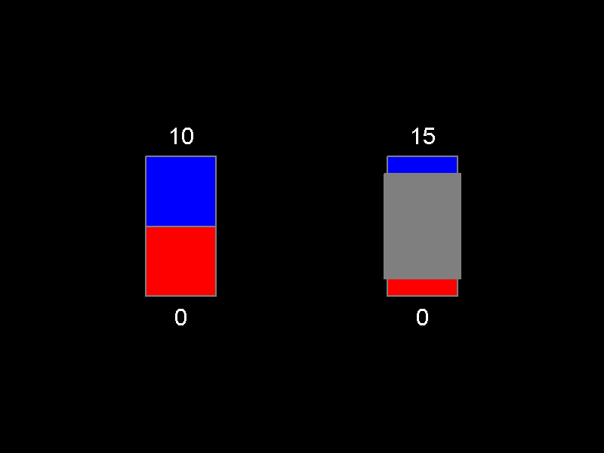

Figure 2.

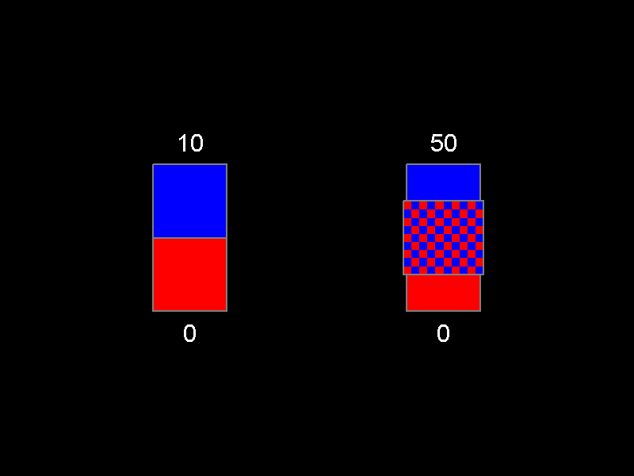

Figure 3.

In the above figures you know the exact proportion of red and blue balls in the left urn but you don’t know the proportion in the urn on the right.

The solid grey occluder in Figure 2 informs that the occluder will remain over the urn for the whole duration of the trial. Conversely, the chessboard occluder informs that the occluder will disappear as soon as you make your decision and the outcome is displayed. In other words, when the solid grey occluder is displayed over the urns, you will never know the exact proportion of blue and red balls inside the urn, whereas, when the chessboard occluder is displayed, the exact proportion of red and blue balls will be informed to you just after you make your decision.

The values in the bottom and in the top of each urn indicate the number of points you will receive if a red or a blue ball, respectively, is drawn from the urn. Thus, if a blue ball is drawn from the right urn in figure 4, you will receive 50 points, whereas, if a red ball is drawn from this same urn, you will not receive any point.

Now, I will describe in more detail how the trials will be presented:

A fixation point “**+**” is shown at the beginning of each trial. When a fixation point is presented on the screen, please, pay attention and be ready for the beginning of the trial.

Next, the two urns are presented and you have to decide if you want to play with the urn on the left or on the right. For making your decision, use the arrow 🡨 and 🡪 of the keyboard.

Once you have made your decision, a white frame will surround the selected urn as shown in the following Figure 4. In this example, the selected urn was the one on the right.

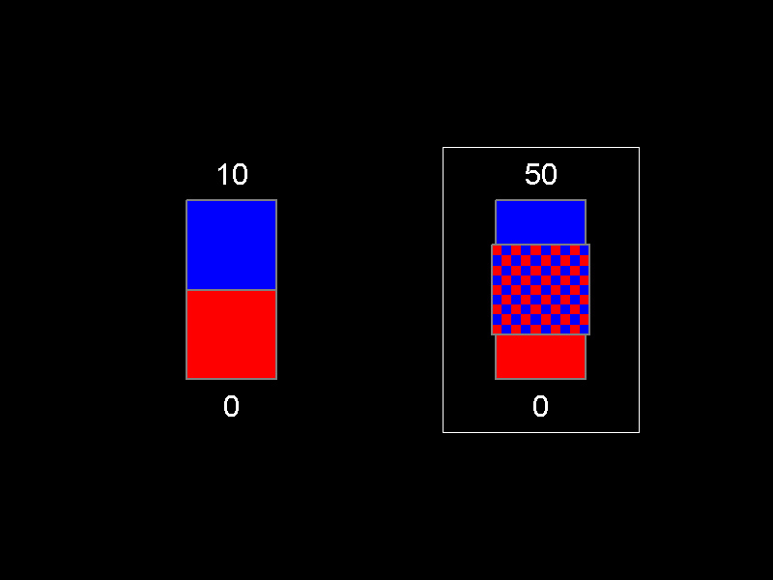

Figure 4.

After a short interval, one ball is drawn from each urn and the number of points that you got from the selected urn and the number of points that would have got, if you had selected the alternative urn, are highlighted in green.

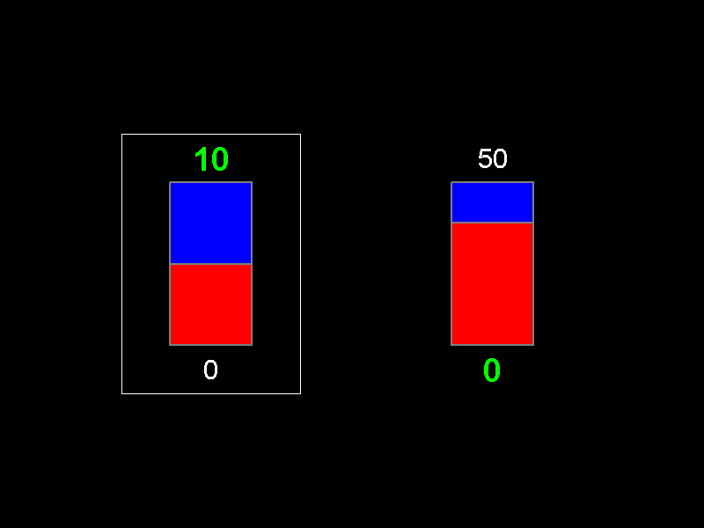

Figure 5.

Before the end of each trial, you will be asked to report your feelings regarding the received outcome. A scale of pleasantness will be displayed in the screen. You will use the arrow 🡨 🡪 keys to report your feelings (for confirming use the space button of the keyboard). For instance, if you felt extremely unhappy regarding the obtained outcome, please, report this feeling choosing the extreme left value in the scale (i.e. extremely unpleasant) as shown below.

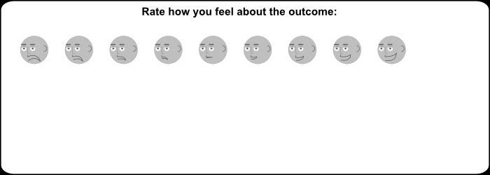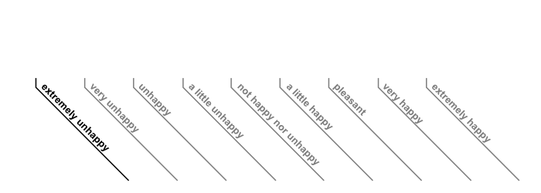



Alternatively, if you felt neutral, select the “not happy nor unhappy” as indicated below. Any other value in this range is also possible. There is no right or wrong answer, so please report your feelings the most sincere you can.

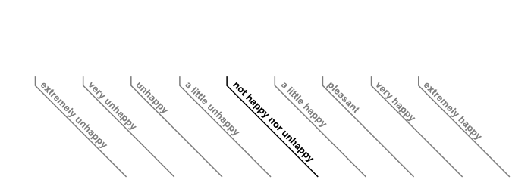



In the end of the experiment, we will randomly select the points received in one of the played trials and this amount will be your final payoff in Euros

Now, please, respond to the following questions which I made in order to certify that you have completely understood the instructions.

If something should not be clear please don’t hesitate to ask for clarifications.

In the Figure below:



* The probability to draw a blue ball is higher in the urn on the right than

the one on the left T F

* Choosing the urn on the left, the probability to draw a blue ball is different

from the probability of drawing a red ball. T F

In the Figure below.



* In the urn on the right you don’t know the exact probability to draw a red or blue ball

and you never will know it. T F

In the Figure below.



* You will never know the composition of the red and blue balls in the urn on the right T F
* The chessboard will disappear when you have made a decision the urn T F

In the figure below:



* How much will be your reward if a red ball is drawn?

* How much will be your reward if a blue ball is drawn?

In the Figure below



* In the urn on the left has been drawn a red ball T F
* In the urn on the right has been drawn a red ball T F
* Your reward is 10 euro T F

Now, you will play a short training session, before the real experiment.

Are there any questions before we begin?

Please keep your mobile phones off or in silent mode during the sessions.

We thank you very much for your participation today.